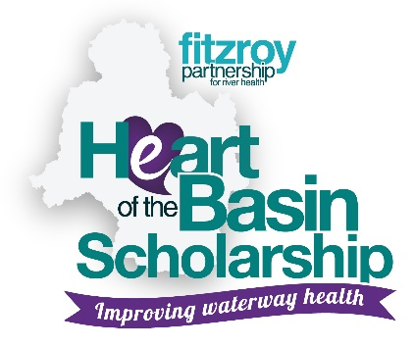

Fitzroy Partnership for River Health
HeART of the Basin CQUniversity Scholarships Programme Application Form

1. PERSONAL DETAILS
Surname
Given Names
Address & Postcode
Telephone Number
Email Address
Date of Birth
Study level and discipline (Honours, Masters, PhD)
Study mode and region
CQUniversity
Student ID Number
Proposed research focus/title

2. ELIGIBILTY CRITERIA

To be eligible, students need to:
- Be enrolled in an Honours, Masters by Research or PhD in a relevant field of research at CQUniversity;
- Be an Australian Citizen or Permanent Resident;
- Be studying on campus in Rockhampton or through distance learning (flexible);
- Devote time during the length of the scholarship (12 months) to an agreed research topic relating to advancing waterway health in the Fitzroy Basin.

3. SELECTION CRITERIA

Applicants will need to provide:
- A submission of no more than 750 words outlining the proposed waterway health research topic and their career aspirations.
- Evidence of an ability to set and achieve career and personal goals.
- Information about academic history and work experience (please attach academic transcript and resume);
- A letter of support from their proposed CQUniversity Project Supervisor.

Question 1: Written submission (please provide as an appendices to this application form)

Question 2: Academic history and work experience (please provide academic transcript and resume as an appendices.)
Question 3: Please provide letter of support as a separate attachment in appendices.
------------------------------------------------------------------------------------------------------------------------

------------------------------------------------------------------------------------------------------------------------

------------------------------------------------------------------------------------------------------------------------

------------------------------------------------------------------------------------------------------------------------

SUBMITTING YOUR APPLICATION

Prior to submission, ensure that your application includes;
− Your resume
− Academic transcript
− Letter of support from your proposed academic supervisor
− Your written submission (750 words max.)

5. DECLARATION BY APPLICANT

I declare that the information provided is true and correct. I have submitted a copy of my completed application plus a personal or work reference.

Applicant’s Signature Date

Please return application to:

Executive Officer
Fitzroy Partnership for River Health
Email: leigh.stitz@riverhealth.org.au

Enquiries regarding the scholarship can be made to Dr Leigh Stitz – leigh.stitz@riverhealth.org.au or phone (07) 4999 2821.

