Georges River Combined Councils’ Committee River Health Report Cards
Georges River Combined Councils’ Committee (GRCCC)
The GRCCC was formed in 1979. The GRCCC's mission is to advocate for the protection, conservation and enhancement of the health of the Georges River, by developing programs and partnerships, and by lobbying government organisations and other stakeholders. Members consist of nine local councils as well as agencies and community representatives within the Georges River catchment. Core funding is provided by member councils: Bayside, Georges River, Canterbury Bankstown, Fairfield, Liverpool, Campbelltown, Wollondilly and Sutherland.
River Health
The River Health monitoring program began in 2009, with funding from a federal Caring for Our Country Grant. It was the first program to assess the ecological condition of the whole Georges River catchment using standardised methods. Whilst funded by the federal grant, the program involved engaging citizen scientists in the collection of data. River Health has continued beyond that granting period and is now funded by member councils, with one full-time staff responsible for coordinating the program. An external review was conducted in 2014 to ensure the protocols used by River Health are robust. Following the recommendations from that review, all data is now collected by professionals.
Riparian Vegetation, Water quality and Macroinvertebrate communities are assessed across 35 freshwater sites in spring and autumn each year. Water quality is assessed across 17 estuarine sites in warmer months of the year, when peak algal production is most likely. Values of parameters and metrics are simplified into grades, which are used on annual Report Cards to facilitate communication with the general public. The Report Card has a map with grades for each site and for subcatchments. Shading of site symbols and subcatchments uses a ‘traffic light’ system to indicate ecological condition (‘Excellent’ shaded dark green, ‘Good’ shaded light green, ‘Fair’ shaded yellow and ‘Poor’ shaded orange). This clearly displays that urbanised subcatchments are more ecologically degraded than undeveloped subcatchments: which is as expected, but not widely understood and Report Cards are useful for educating the general public. Although citizen scientists are no longer involved in collection of the data that informs River Health grade determination, community engagement remains an important role of GRCCC.
In addition to the map, the Report Card also has information explaining the problem of waterway degradation in urban areas and solutions. Waterway management initiatives of member councils are displayed to communicate their good work. Report Cards are an important tool for educating the community and aid in fostering a sense of partnership between councils and the public to care for local waterways in the Georges River catchment. See: http://www.georgesriver.org.au/River-Health-Report-Cards.html

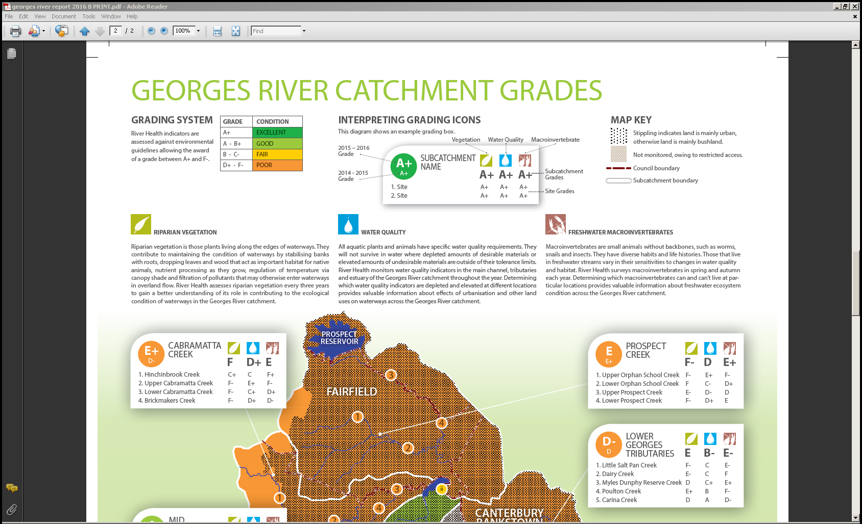
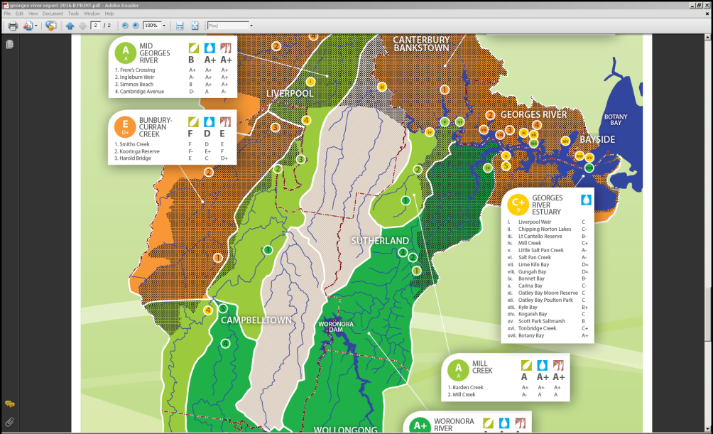
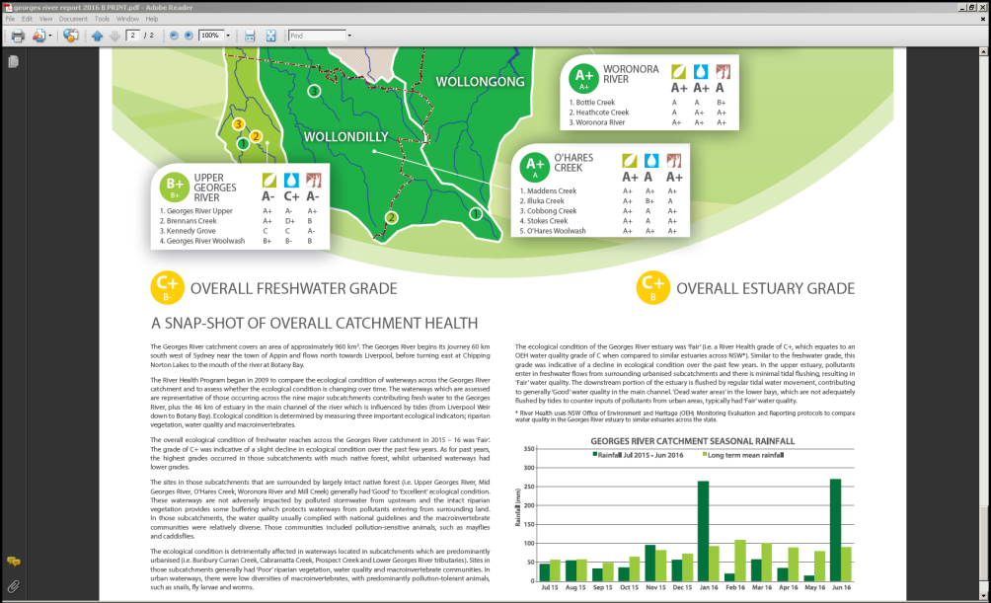
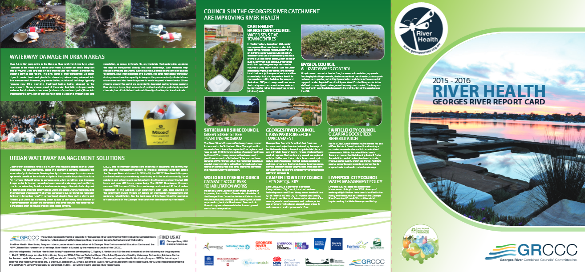

Georges River Combined Councils’ Committee Riverkeeper Report Cards
Georges River Combined Councils’ Committee (GRCCC)
The GRCCC was formed in 1979. The GRCCC's mission is to advocate for the protection, conservation and enhancement of the health of the Georges River, by developing programs and partnerships, and by lobbying government organisations and other stakeholders. Members consist of nine local councils as well as agencies and community representatives within the Georges River catchment. Core funding is provided by member councils: Bayside, Georges River, Canterbury Bankstown, Fairfield, Liverpool, Campbelltown, Wollondilly and Sutherland.
Riverkeeper
The Riverkeeper Program has been continuous since 1997, with responsibility for coordinating litter removal from foreshores and tributaries, plus bush regeneration across the Georges River catchment. Annual Riverkeeper Report Cards have been produced since 2011.
Those Report Cards have maps for the Upper, Middle and Lower Georges River subcatchments, showing:
- Total amount of litter collected, total hours spent collecting litter, total area on bush regeneration, total hours spent on bush regeneration and total number of plantings across the Georges River catchment
- Total amount of litter collected across each subcatchment
- Amount of litter collected at ‘hotspot’ sites
- Amount of hours spent collecting litter
- Area of bush regeneration completed in each Local Government Area
- Amount of hours spent on bush regeneration
- Locations of litter removal and bush regeneration
The Report Card also gives credit to partners who support the work of the Riverkeeper. In recent years, the federal government’s Green Army Programme was a valuable resource that aided member councils in bush regeneration and litter collection, whilst the bulk of litter collection is performed by teams of NSW Corrective Services offenders on Community Correction orders. GRCCC manage and oversee the Aboriginal Riverkeeper Team, with federal funding for the ‘Building Indigenous Knowledge and Skills in Restoring Urban Waterways’ project. The successes of the ART have been summarised on recent Report Cards. See: http://www.georgesriver.org.au/Riverkeeper-Program.html

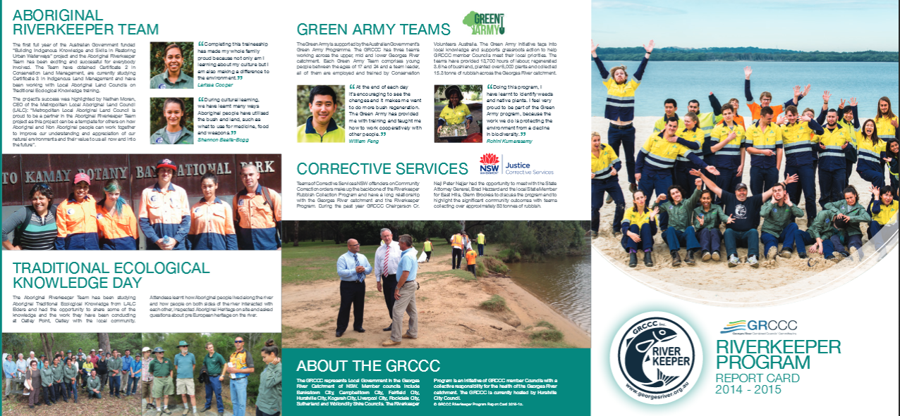

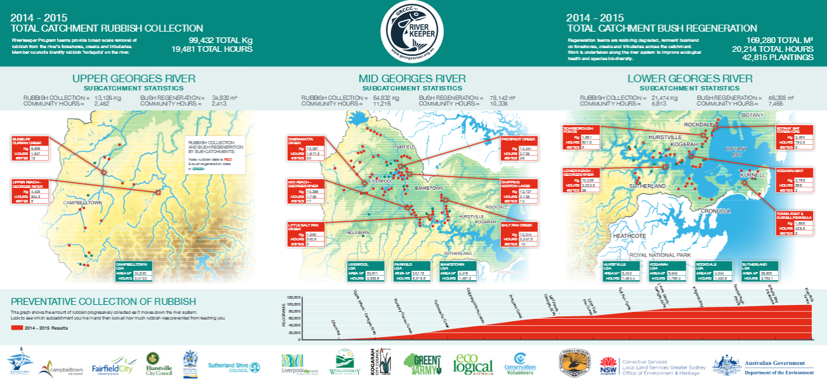

Using protocols of Findlay S, Taylor M, Davies P & Fletcher A (2011). Development and application of a rapid assessment tool for urban stream networks. Water & Environment Journal 25: 2-12.
Water quality parameters include pH, turbidity, electrical conductivity, dissolved oxygen, total nitrogen, ammonia, nitrates-nitrites, total Kjeldahl nitrogen, total phosphorus and soluble reactive phosphorus.
Based on protocols of DEST, EPA, & WRDC. (1994) River bioassessment manual. Version1.0, National River Processes and Management Program, Monitoring River Health Initiative. Canberra: Department of Environment, Sport and Territories, Environment Protection Agency, and Land and Water Research and Development Corporation. Metrics are taxon richness, Shannon-Weiner diversity and SIGNAL-2 scores.
Using protocols of Office of Environment and Heritage (OEH) (2013). Assessing estuary ecosystem health: sampling, data analysis and reporting protocols. Office of Environment and Heritage, Sydney.
Based on the grading system of Healthy Waterways: EHMP (2008): Ecosystem Health Monitoring Program 2006-07 Annual Technical Report. South East Queensland Healthy Waterways Partnership, Brisbane. Centre for Environmental Management, Central Queensland University.

